**IDEATION:**

**Arduino Mega Board:**

Arduino is an open-source electronics prototyping platform based on flexible, easy-to-use hardware and software. Its intended for artists, designers, hobbyists, and anyone interested in creating interactive objects or environments. Or more simply, you load on some code and it can read sensors, perform actions based on inputs from buttons, control motors, and accept shields to further expand its capabilities. Really, you can do almost anything. All Arduino boards have one thing in common: they are programmed through the Arduino IDE. This is the software that allows you to write and upload code. Beyond that, there can be a lot of differences. The number of inputs and outputs (how many sensors, LEDs, and buttons you can use on a single board), speed, operating voltage, and form factor are just a few of the variables. Some boards are designed to be embedded and have no programming interface (hardware) which you would need to buy separately. Some can run directly from a 3.7V battery, others need at least 5V.

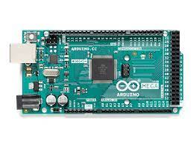

**Liquid-crystal display (LCD):**

It is a flat-panel display or other electronically modulated optical device that uses the light-modulating properties of liquid crystals. Liquid crystals do not emit light directly, instead using a backlight or reflector to produce images in color or monochrome.[1] LCDs are available to display arbitrary images (as in a general-purpose computer display) or fixed images with low information content, which can be displayed or hidden, such as preset words, digits, and seven- segment displays, as in a digital clock.

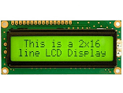

**Temperature and PH sensor:**

To measure the temperature of a water tank and log it via the Arduino. The idea is to maintain the temperature of the water at 25-30C at all times. I've noticed that most applications have used a sensor such as DS18S20 or TMP35/TMP36/TMP37. but since my application requires to measure the temperature in water, I think a more suitable sensor should have a waterproof probe (or external probe). The usual way is to contain the water inside a tank / container which can transmit heat – usually metal. To the outside of this is then bonded the temperature sensor – be that a simple bi- metallic strip thermostat, or a more complex temperature sensing transducer. Of course, this requires a metal tank, and that will radiate heat, which will be wasteful. Ideally you would want some form of waterproof probe. You haven't mentioned the amount of water you're dealing with – how big is the tank? How deep especially. There are thermocouples available in a rigid probe form – quite how waterproof these are I'm not sure, but these are never very long, so you won't be able to get it more than 6 inches or so into the water before you risk complete submersion.

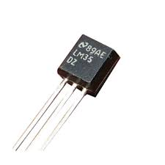

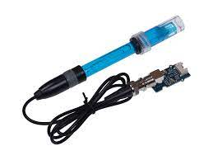

**The Turbidity Sensor:**

Turbidity is an indicator often used to find the amount of suspended sediment in water. By cumbersome mechanical sampling, it is possible to measure the concentration of suspended solids (in mg/ l) in water, but turbidity is increasingly used instead, as it is easy to use and cheaper too. It is an ecologically important parameter as the various effects of suspended solids in aquatic ecosystems are due to their light scattering properties rather than their absolute mass.

